**1.What are the two values of the Boolean data type? How do you write them?**

Two values of Boolean data type are True and False

These are written as: (capital first letter)

True

False

**2. What are the three different types of Boolean operators?**

And

Or

not

**3. Make a list of each Boolean operator's truth tables (i.e. every possible combination of Boolean values for the operator and what it evaluate ).**

|  |  |  |  |  |  |  |  |  |  |
| --- | --- | --- | --- | --- | --- | --- | --- | --- | --- |
| **AND truth table** | | |  | **OR truth table** | | |  | **NOT truth table** | |
| **Input** | **Input** | **Result** | **Input** | **Input** | **Result** | **Input** | **Result** |
| True | True | True | True | True | True | True | False |
| True | False | False | True | False | True | False | True |
| False | True | False | False | True | True |  | |
| False | False | False | False | False | False |

**4. What are the values of the following expressions?**

**(5 > 4) and (3 == 5)** =False

**not (5 > 4)** = False

**(5 > 4) or (3 == 5)** = True

**not ((5 > 4) or (3 == 5))** = False

**(True and True) and (True == False)** = False

**(not False) or (not True)** = True

**5. What are the six comparison operators?**

==, !=, <, >, <=, and >=

**6. How do you tell the difference between the equal to and assignment operators?Describe a condition and when you would use one.**

== or equal to operator is used to verfy the expression and it returns Boolean values where as = or assignment operator is used to assign a value to a variable.

Ex. if we want to compare whether two integers are equal then we use equal to operator but if we want to assign a integer value to a variable then we use assignment operator.

**7. Identify the three blocks in this code:**

**spam = 0**

**if spam == 10:** //block1 start

**print('eggs')** //block1 end

**if spam > 5:** //block2 start

**print('bacon')** //block2 end

**else:** //block3 start

**print('ham')**

**print('spam')**

**print('spam')** //block3 end

**8. Write code that prints Hello if 1 is stored in spam, prints Howdy if 2 is stored in spam, and prints Greetings! if anything else is stored in spam.**

if spam ==1:

print("Hello")

elif spam == 2:

print("Howdy")

else :

print("Greetings!")

**9.If your programme is stuck in an endless loop, what keys you’ll press?**

CTRL-C

**10. How can you tell the difference between break and continue?**

Break is used to terminate the execution of remaining iteration of the loop whereas continue is used to terminate only the current iteration of loop

**11. In a for loop, what is the difference between range(10), range(0, 10), and range(0, 10, 1)?**

range(10) tell the program when to stop in this case at 10.by default start point is 0 and increment is 1. And stop point (10) is excluded.

range(0,10) tell the program where to stop and where to end in this case start at 0 and end at 10. by default increment is 1. And stop point (10) is excluded.

**12. Write a short program that prints the numbers 1 to 10 using a for loop. Then write an equivalent program that prints the numbers 1 to 10 using a while loop.**

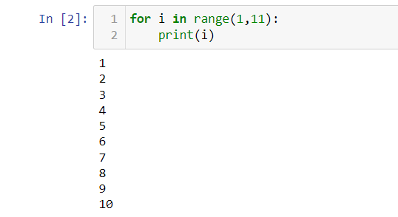 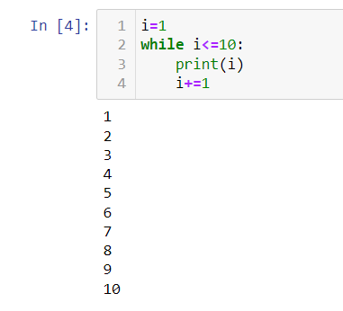

**13. If you had a function named bacon() inside a module named spam, how would you call it after importing spam?**

